Muath Almubarrizi

Add Numbers

*Specifications for Add Numbers*

**Introduction**

The add number application allows the user to enter multiple entries of shim weights while keeping track of each individual one and a running total of the whole specified bag. A user can specify the weight of said bag, multiple status information indicates the status of the size and number of entered shims. Finally the user is able to print out a detailed slip of the information he provided in a label form that includes a count of shims, a total weight of said shims, an average, a minimum and maximum and finally a standard deviation of the weights the user have entered.

**Inputs**

Data: collection of multiple weighted shims.

Input field: this field allows the user with controlled matter to enter the desired shim weight.

A list box of entries: this list box keeps track of all entered shims weights that a user have input into the program.

Clear last entry: This button will clear that last entered entry by the user.

Set bag size: This button will allow the user to input a specified size for the maximum weight of a shim bag.

**Outputs**

1. The user is prompted after he finishes entering the data to print out a label that includes

* Count of shims he entered.
* Total Weight of shims.
* Standard deviation of weights.
* Minimum weight of entered shim.
* Maximum weight of entered shim.
* Average weight of shims entered.

These information are calculated without the user interaction to provide the user with as much information as he requires.

**Acceptance Criteria**

The program have one goal that is to assist the user to enter a number of shims while keeping track of their count and weight, the user have the option to specify the weight. The program will save the user entries and preform mathematical equations on the entered data, while also protecting the user from malformed entries or invalid ones. When the limit of the bag of shims is reached the user will be able to print a detailed label that will provide him with information regarding his bag of shims.

Architectural Design

**Use Cases**

This application has one use case. That is to assist a user in weighting shims and packaging them into a specified bag size and providing the user with detailed information about the whole process.

**Application Overview and Technology**

The Add Number Program will be a Windows form application designed to run on a Windows computer. The program will be developed using Microsoft Visual Studio using c#. No additional frameworks or technologies should be need.

**Design Patterns**

This application uses minimum dependency on the .Net frameworks required by C# language. Aside from requiring those the program requires nothing else to run. Its fully depended developed for one task that is to take in shims weight and process them into meaningful information that will assist the user into having an organized inventory of his shims.

This program only provides a user interface that prompts the user to enter his data, and an optional requirements of a printer to print out a detailed finished report of processed data from the user input.

**User Interface**

The application consist of two primary user interface, one for input and one for output

below is a figure of said interfaces with dummy data to showcase the program functionality.

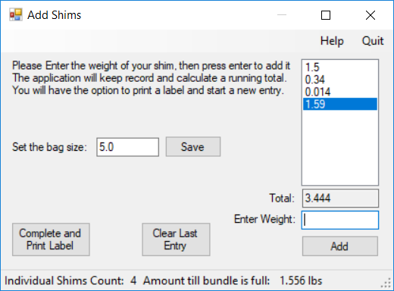  
Illustration 1: The main window of the application

In illustration 1 the main window of the application is shown on the right side of the main window the user is prompted to enter a weight of a shim

Also a multiple options provided to the user from visualizing the entries and a running total to an interactive button named “Clear last Entry” that allows the user to undo his last entry.

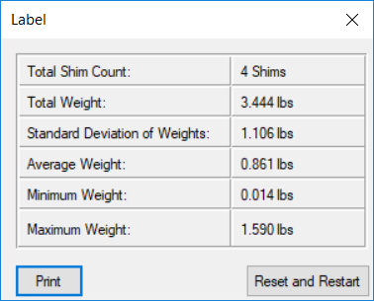  
Illustration 2: The print label window shows the user the final processed results of his input

In illustration 2 after the user picks the option to print his label, he is shown a detailed information about his input formatted as per the requirements to allow him to either print or revert back and restart his entry or start a new one.

**Data-flow diagram**

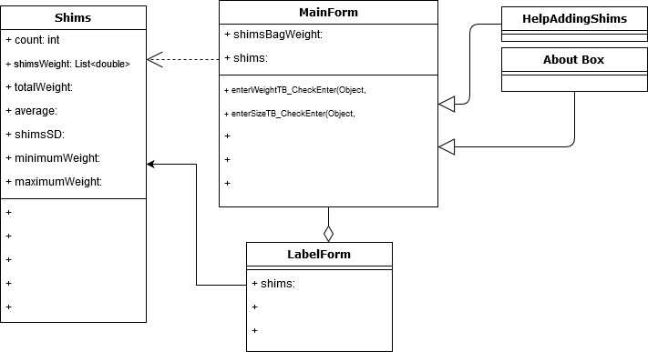

Test Criteria

|  |
| --- |
| **Criteria** |
| Entering numerical values |
| Running total |
| Track of shim counts |
| Last entry removal |
| Bag size limit |
| Override size limit |
| Detailed label information |
| Quit option |
| Help option |
| About option |
| Size till full bag |

**Maintenance and future upgrades**

The application is released with all the requirements accomplished, nevertheless maintenance is expected, the application could benefit from having the ability to read the weight directly from the scale where the shim is placed, requiring less effort from the user to input the weight and instead just confirm the read out.

Automating printing of the label upon reaching the targeted bag size is also an idea looking forward too.